


2022 Community mental health survey

Variation in trust results: Trusts where patient experience is better or worse

NHS Patient Survey Programme

Published: October 2022
Contents
Contents 1
Summary 2
Better than expected 2
Worse than expected 2
Interpreting the results 3
Results 4
Trusts achieving ‘better than expected’ results 4
Trusts achieving ‘worse than expected’ results 5
Appendix A: Analysis methodology 6
Identifying worse than expected experience 6
Identifying better than expected experience 6
Weighting 7
Scoring 7
Appendix B: Analytical stages of the outlier model 8
Appendix C: Difference between outlier analysis and trust-level benchmark reports 11
Appendix D: Date of published CQC ratings 12
Appendix E: Further information 13

Summary
The 2022 community mental health survey received responses from 13,418 people who were receiving treatment for a mental health condition, between 1 September 2021 and 30 November 2021. National results can be found on our website.
This analysis identifies NHS trusts where experiences of care were better or worse when compared with survey results across all trusts in England. The analysis method used in this report allows for an overall picture of performance across the survey as a whole, considering results for all evaluative (scored) questions simultaneously. It supplements the approach used in trust level benchmark reporting, which provides results for individual questions.
Each trust has been assigned one of five bands according to their overall performance across the survey: ‘much worse than expected’, ‘worse than expected’, ‘about the same’, ‘better than expected’ or ‘much better than expected’. Appendix C provides further information on the different approaches used to explore variation in people’s experience between trusts.
In 2022, one trust was categorised within the highest band of ‘much better than expected’ and three trusts were categorised within the lowest band of ‘much worse than expected’. Outlier analysis was not produced in 2020 due to the impact of COVID-19 and the national lockdown on trust-level results. In 2021, no trusts were categorised within the highest band of ‘much better than expected’ or the lowest band of ‘much worse than expected’.
Better than expected
NAVIGO Health and Social Care CIC has been in the ‘better than expected’ category since 2018. The banding for NAVIGO Health and Social Care CIC has moved from ‘better than expected’ to ‘much better than expected’ in 2022.
Worse than expected
North Staffordshire Combined Healthcare NHS trust, Sussex Partnership NHS Foundation Trust and Birmingham and Solihull Mental Health NHS Foundation Trust have all been in the ‘about the same’ category since 2018. The banding for these three trusts has moved to ‘worse than expected’ for 2022.

CQC’s Deputy Chief Inspector of Hospitals and lead for mental health, Jemima Burnage, has written to all trusts identified as better or worse than expected. The trusts identified as being worse will be asked to review their results and to outline what actions they will take to address the areas of concern. CQC will continue to reflect each trust’s performance on this survey within our monitoring tools as part of the wider information we have on how trusts are performing.
Interpreting the results
To provide a comprehensive picture of people’s experiences of community mental health services within each NHS trust, we have calculated the overall proportion of responses that each trust received for the ‘most negative’ and ‘most positive’ answer option(s) across all scored questions in the survey.
The following question from the 2022 community mental health survey demonstrates how responses are categorised as either ‘most negative’, ‘middle’ and ‘most positive’.
Q7. Were you given enough time to discuss your needs and treatment?
- Yes, definitely – most positive
- Yes, to some extent – middle
- No – most negative
- Don’t know/can’t remember – excluded from the analysis
Where people’s experience of using a trust’s services are either better or worse than other trusts, there will be a significant difference between that trust’s result and the average result across all trusts. Each trust is then assigned a banding of either ‘much worse than expected’, ‘worse than expected’, ‘about the same’, ‘better than expected’ or ‘much better than expected’ depending on how significant that variation is.
For example, if a trust’s proportion of responses breaks down as: ‘most negative’ 28%, ‘middle’ 25% and ‘most positive’ 47%. This is then compared with the trust average of ‘most negative’ 22%, ‘middle’ 24% and ‘most positive’ 54%. The adjusted z-score for the difference between the example trust’s ‘most negative’ proportion (28%) and the trust’s average 'most negative’ proportion (22%) is -2.50. This means this trust has a higher proportion of ‘negative’ responses than average, this is considered significant with a p-value of less than 0.025 but not less than 0.001. As a result, the trust is classed as ‘worse than expected’.
Finally, each table in the report includes the most recent trust-wide CQC rating. See Appendix B for details of the analytical method used to calculate these results.

Results
Trusts achieving ‘better than expected’ or ‘much better than expected’ results
No trusts were classified as being ‘better than expected’ in 2022, however one trust was classed as ‘much better than expected’.

NAVIGO Health and Social Care CIC has been in the ‘better than expected’ category since 2018. The banding for NAVIGO Health and Social Care CIC has moved from ‘better than expected’ to ‘much better than expected’ in 2022.

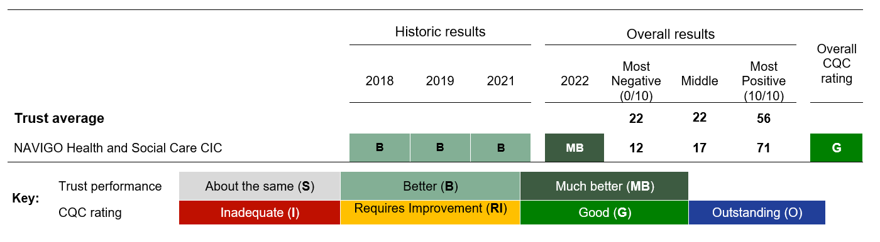

Trusts achieving ‘worse than expected’ or ‘much worse than expected’ results
Three trusts were identified as ‘worse than expected’ this year across the entire survey. No trusts were identified as being ‘much worse than expected’.

North Staffordshire Combined Healthcare NHS trust, Sussex Partnership NHS Foundation Trust and Birmingham and Solihull Mental Health NHS Foundation Trust have all been in the ‘about the same’ category since 2018. The banding for these three trusts has moved to ‘worse than expected’ in 2022.

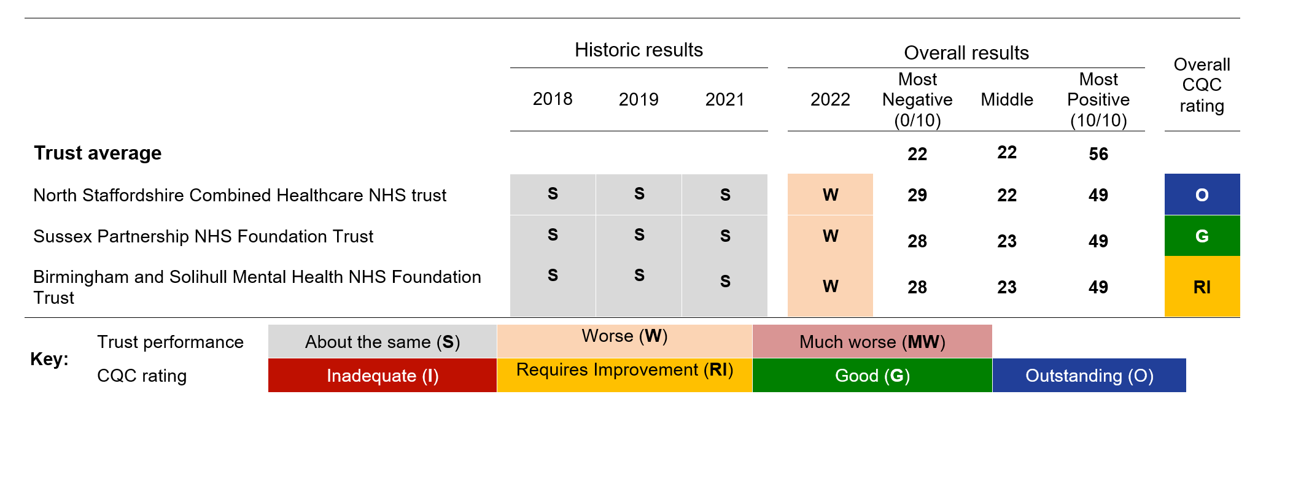

Appendix A: Analysis methodology
Identifying worse than expected experience
The analytical approach to identifying those trusts where people’s experiences of services was ‘worse/much worse than expected’ uses responses for all scored questions (except the overall experience question).
For each trust, we calculate the number of responses scored as ‘0’ (the most negative option). This is then divided by the total number of responses scored as 0-10 to calculate the trust-level proportion of poor experience. A higher percentage of negative responses indicates poorer experience.
The analysis uses z-scores, which indicate how different a trust’s poor experience proportion is from the average.
There are two thresholds for flagging trusts with concerning levels of poor experience:
- Worse than expected: z-score lower than -1.96

- Much worse than expected: z-score lower than -3.09
Appendix B provides full technical detail of the analytical process used.
Identifying better than expected experience
To identify ‘much/better than expected’ experience, we calculate a count of the number of responses scored as ‘10’ (the most positive option) for each trust.
This is then divided by the total number of responses scored as 0 to 10 to calculate the trust-level proportion of positive experience. A higher percentage of positive responses indicates better experience.
Our analysis has found that those trusts with the highest proportion of positive responses also tend to have the lowest proportion of negative responses.
There are two thresholds for identifying trusts with high levels of good experience reported by people using services:
- Better than expected: z-score lower than -1.96

- Much better than expected: z-score lower than -3.09
Weighting
Results have been standardised by the age and sex of respondents to ensure that no trust will appear better or worse than another because of its respondent profile.
Standardisation enables a more accurate comparison of results from trusts with different population profiles. In most cases this will not have a large impact on trust results, but it does make comparisons between trusts as fair as possible.
Scoring
For each question in the survey, the individual (standardised) responses are converted into scores on a scale from 0 to 10. A score of 10 represents the best possible response and a score of 0 the worst. The higher the score for each question, the better the trust is performing.
It is not appropriate to score all questions in the questionnaire as not all questions assess trusts’ performance. For example, they may be descriptive questions such as Q1 which asks a respondent ‘when was the last time you saw someone from NHS mental health services?’.

Appendix B: Analytical stages of the outlier model

The analytical approach to identifying outliers is based on all evaluative items in the survey. These are the questions that are scored for benchmarking purposes. The scored variables are the source data and are required at respondent level. These variables take values between 0 (representing the worst rating of experience) and 10 (representing the best rating of experience). The approach also makes use of the standardisation weight for the survey.

1. Count the poor-care ratings made by each respondent
Count of the ‘0’ responses across the scored questions answered by each respondent (excluding the ‘Overall…’ question).

2. Count the questions given specific (scored) answers by each respondent
Count of all ‘0 to 10’ responses across the scored questions answered by each respondent (excluding the ‘Overall…’ question).

3. Weight the data
Apply the standardisation weight for respondents. The weight adjusts the population of respondents in each trust to the national average proportions for age and sex.

4. Aggregate to trust-level and compute proportion of poor ratings
Obtain a weighted numerator and denominator for each trust. Divide the numerator by the denominator to obtain the trust-level proportion of poor care ratings, for example the overall percentage of responses which were scored as 0.

5. Compute the mean of the trust-level proportions
Sum all proportions and divide by the number of trusts to obtain the average trust-level proportion of poor care ratings.
6. Compute the z-score for the proportion
The Z-score formula used is:
(1)
where: is the denominator for the trust.
is the trust proportion of poor care ratings.
is the mean proportion for all trusts.

7. Winsorize the z-scores
Winsorizing consists of shrinking extreme Z-scores to a selected percentile, using the following method:

1. Rank cases according to their naive Z-scores.
2. Identify Zq and Z(1-q), the 100q% most extreme top and bottom naive Z-scores. For this work, we used a value of q=0.1.

3. Set the lowest 10% of Z-scores to Zq, and the highest 10% of Z-scores to Z(1-q). These are the Winsorized statistics.
This retains the same number of Z-scores but discounts the influence of outliers.

8. Calculate dispersion using Winsorized z-scores
An over dispersion factor is estimated which allows us to say if the data are over dispersed or not:
(2)

Where I is the sample size (number of trusts) and zi is the Z score for the ith trust given by (1). The Winsorized Z scores are used in estimating .

9. Adjust for overdispersion
If I is greater than (I - 1) then we need to estimate the expected variance between trusts. We take this as the standard deviation of the distribution of pi (trust proportions) for trusts, which are on target, we give this value the symbol, which is estimated using the following formula:
(3)
where si = (pi-po)/zi, wi = 1/si2 and is from (2). Once has been estimated, the ZD score is calculated as:
(4)

Appendix C: Difference between outlier analysis and trust-level benchmark reports
The approach used to analyse trust variation in this report is focused on identifying significantly higher levels of better or worse experience across the entire survey.
This holistic approach is different to the technique used to analyse results in trust benchmarking reports. In these reports, trust results for each scored question are assigned bands of either ‘much better’, 'better', ‘somewhat better’, 'about the same', ‘somewhat worse’, ‘worse’, ‘much worse’ when compared with the findings for all other trusts. Trust benchmark reports do not look across all questions concurrently and therefore do not provide a summative assessment of the proportion of positive or negative experiences reported across the entire survey.
The approach used in this report allows CQC to identify potential concerns raised by people across the survey in its entirety.

Appendix D: Date of published CQC ratings
The following table provides the most recent publication date of CQC Inspection ratings, provided within the results section of this report.

Better than expected trusts
Provider name | Overall trust rating | Date
NAVIGO Health and Social Care CIC | G | 11/12/2019

Worse than expected trusts
Provider name | Overall trust rating | Date
North Staffordshire Combined Healthcare NHS trust | O | 28/03/2019
Sussex Partnership NHS Foundation Trust | G | 07/06/2019
Birmingham and Solihull Mental Health NHS Foundation Trust | RI | 05/04/2019

Appendix E: Further information
The results for England and trust level benchmark results are available on CQC’s website. You can also find a technical document here, which describes the method for analysing trust level benchmark results.

Full details and supporting documents for this survey can be found on the NHS surveys website. This includes full details of the methodology for the survey, questionnaires, scored questionnaire, letters sent to service users, instructions on how to carry out the survey and the survey development report.

More information on the patient survey programme, including results from other surveys and a programme of current and forthcoming surveys can be found on the CQC website.
How to contact us

Call us on: 03000 616161

Email us at: enquiries@cqc.org.uk

Look at our website: www.cqc.org.uk

Write to us at: Care Quality Commission
Citygate
Gallowgate
Newcastle upon Tyne
NE1 4PA
Follow us on Twitter: @CareQualityComm

Please contact us if you would like a summary of this document in another language or format.

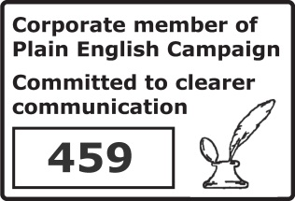

. Filter questions were not included in this analysis.
A p-value is a measure of the probability that an observed difference could have occurred just by random chance.
. Overall experience is excluded from the analysis due to the ambiguity around what should be classed as the ‘most negative’ (and ‘most positive’) option(s).
. The analytical approach used to identify positive experience of people using services uses a numerator count of the ‘10’ responses across all scored questions (excluding the ‘overall…’ question) to calculate the ‘good-care ratings’. There are no other differences between the analytical approaches for identifying poor and good experience.

